Student’s Name
Professor’s Name
Course
Date of Submission
Visual Argument Analysis of Two Images
Introduction
The two images analyzed in this paper represent the concept of self-image. The first image illustrates how a mother can be essential in passing down the values and standards through which her son creates his self-image as he grows older. Conversely, the second image symbolizes how one can create a flattering but false self-image to escape the reality of one’s actual image. As such, the two images represent two aspects of self-perception, with one exemplifying the early childhood years in which we form the foundations for our self-image due to our parents’ influence, and the other representing how adopting harmful standards of self-perception can lead us into forming the wrong image about ourselves.
Image 1
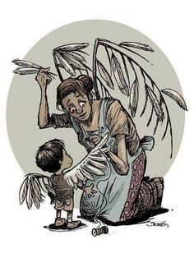
From this first image, we can identify a mother who is dedicated to helping her son build his self-image. The look of concern on the mother’s face as shown by her raised eyebrows, attests to the motherly instinct that creates a genuine interest in how her son perceives himself. Since the mother is seemingly plucking feathers from her wings and sewing them onto her son’s wings using a sewing needle and thread, the feathers symbolize values being passed down from the mother to her son. These wings will enable the son to fly, thereby epitomizing how the values he acquires from his mother will help him create his self-image. The mother’s lips are also slightly separated, as if she is saying some soothing words to her son to reassure him that he matters, thereby enhancing his self-image. The son smiles back, feeling the warmth of his mother’s care and reassuring words. These words, and the values he learns from his mother, will form the foundation for how he perceives himself as he grows older.
In the image, we can also infer the sacrificial nature of the mother’s attempts to fortify her son’s self-image. For starters, the mother has knelt, which is an uncomfortable position for her. Additionally, her hair is scantily tied in an untidy bun, with some strands falling onto her face. This conveys her dedication to sewing feathers onto her son’s wings, such that she has little regard for her appearance. She also does not mind losing some of her feathers in ensuring that his son’s wings are full of feathers. Moreover, the mother also looks emaciated since her arms are significantly slender, thus typifying that she sacrifices even her food for her son’s wellbeing. This is because she understands that her son’s wellbeing is essential in enabling him to form a positive self-image of himself. Nonetheless, the mother does not overtly show that she is uncomfortable when making these sacrifices.
Image 2
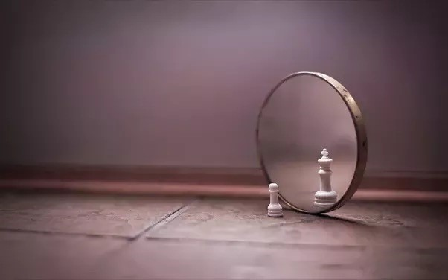
This second image represents the creation of a false and flattering self-image through the pawn’s reflection. Although the pawn is not a king, it views itself as one, signifying how it has managed to create a false self-image based on delusions of grandeur. Since the king is only just a reflection, it symbolizes the contrast between abstract self-perception and reality. In reality, the pawn is just a small chess piece with limited power, yet its abstract self-image is that of a king which is the most privileged and protected chess piece. The floor on which the pawn stands appears dilapidated, which symbolizes the state of powerlessness and deprivation from which the pawn seeks to escape. To escape this reality, the pawn perceives itself as a king, who is not only significantly bigger in proportion but also has more embellishments that symbolize luxuries, such as the crown and the cross on top. The king also occupies a larger space due to its wider base, which signifies that it has more influence. Additionally, the reflection around the king inside the mirror is blurred to suggest that the pawn is deliberately ignoring other factors of reality in making up its false self-image.
The mirror represents the harmful standards that the pawn uses to form its false self-image. The mirror has clear margins, which stands for the boundaries created by these standards of self-perception. The mirror is also surrounded by a frame that enables it to stand upright, symbolizing the moral nature of these standards. Furthermore, the frame appears metallic, which signifies how these standards are strongly held by the pawn. The frame, however, symbolizes the self-imposed limits within which the pawn forms its self-image. Nonetheless, the metallic frame appears to have a copper tinge, signifying that it is made of copper which is a malleable metal. This testifies to the flexibility of the limits within which the pawn creates its self-image, suggesting that the pawn can alter these limits. The metallic frame also seems worn-out because it has several dents, scratches, and places where its color has flaked off. This conveys that the limits within which the pawn views itself have existed for a long time. This alludes to the fact that the pawn has held onto these self-imposed limits for a long time during its existence.

Works Cited
Image 1 (write the sources of image 1)
Image 2 (write the source of image 2)

